System Design Document

Project Executive Summary
MyDay is a social media or blogging web platform written in Java, with time slice feature that allows user to public and comment information that is actual only during 24 hours.

2. SYSTEM ARCHITECTURE
Project is implementing MVC pattern.
Used entities are described as model object and are being stored in the database.
DAO interfaces are describing possible data CRUD operations and are implemented by Controllers.

3.DATABASE DESIGN

Predefined ‘myday’ schema contains following tables that store object information:

Account table stores information about user :
Account ID (auto incremented field)
Login
Password
First name
Last name
User creation date
User last visit date

Post table stores posts information :
Post ID ( auto incremented field)
Post Title
Date when post created
Date when post was last updated
Post author ID
Post text message

Comments table store comment information:
Comment ID (auto incremented field)
Post ID of parent post for this comment
Comment author ID
Comment text message
Creation date

Visitors table store information about page visited by users and guests:
Visit ID (auto incremented field)
URL of the visited page
Account ID if user passed authorization
Referring link
Time stamp of the visit

Following diagram describes relation between tables :
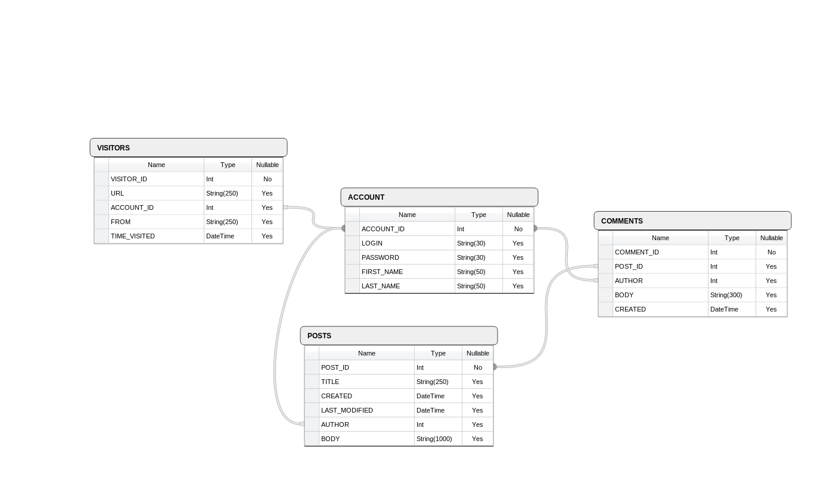
Note: You can use prepared SQL file, that will initialize and prepare database to work with project. It’s included into distributed package.

4. TECHNOLOGIES USED

Project is written in Java using Spring MVC framework.
Database used is MySQL 5.5.38
Build tool : Maven2
Tests : JUnit 4
Webserver : Apache Tomcat

Version control system : Git
You can download project source code and documentation by cloning Git repository from https://github.com/f0r31gn3r/myday_java.git

